**STANDARD INTEGRATION FORMULAS:**

1. ***Integration of Algebraic Functions***
3. ***Integration of Logarithmic and Exponential Functions***

1. ***Integration of Trigonometric Functions***
2. ***Integration of Inverse Trigonometric Functions***

**Activity #1**







**Activity #2**



**Activity #3**

**Activity #4**

**Quiz #1**

**SET B Part 1**

**SET B Part 2**

**SET B**

**Solve**

**Solve**

**Pagsama na natin :3**

**From:**

***to***

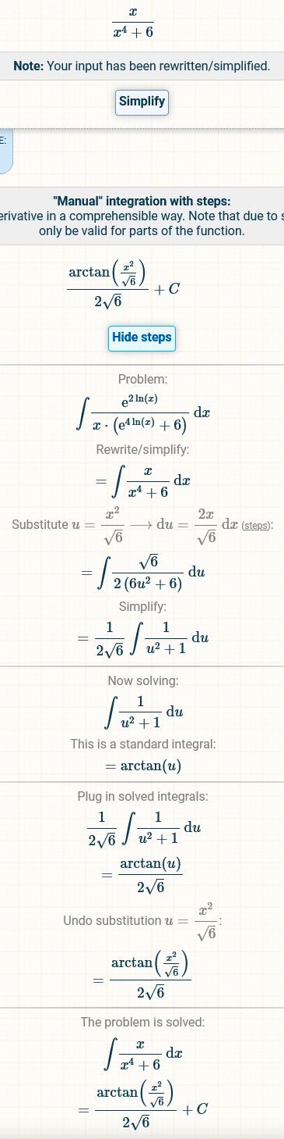

**SET A**

